LAB REPORT: COMPUTER VISION AND IMAGE PROCESSING
Submitted by: Ishmal Nadeem
Roll No: SU92-BSAIM-F24-101
Submitted to: Sir Rasikh
Lab Task: 05

1. Task Objective
The objective of this laboratory task is to implement fundamental image processing techniques using the OpenCV library in Python. The focus is on digital image representation, color space manipulation, and visual data analysis.

2. Technical Requirements & Libraries
The following libraries were utilized in this project:
- OpenCV (cv2): The primary library for computer vision tasks, used for reading, transforming, and processing images.
- NumPy: Used for numerical operations, as images are treated as multi-dimensional arrays (matrices) in Python.
- Matplotlib (pyplot): Used to visualize and display images directly within the Jupyter Notebook environment.

3. Implementation Details & Core Logic

A. Image Acquisition (Reading the Image)
The first step involves loading a digital image from the local storage.
- Function Used: cv2.imread()
- Purpose: This function reads the image and converts it into a NumPy array of pixel intensities. It is the entry point for any computer vision pipeline.
- 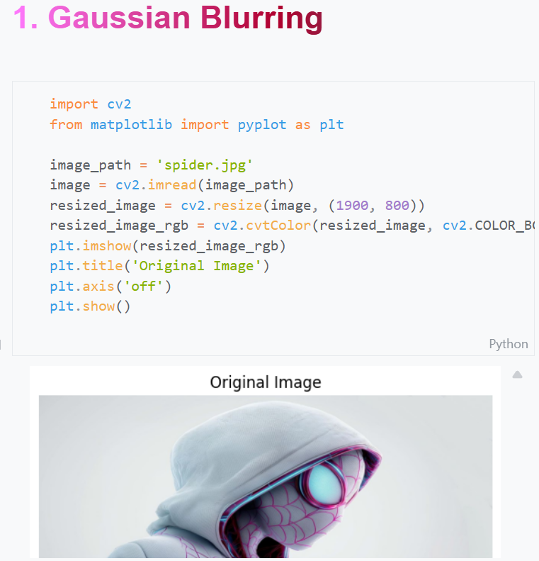

B. Color Space Conversion
OpenCV uses the BGR (Blue, Green, Red) color model by default. However, for standard display and processing, conversions are necessary.
- Functions Used: cv2.cvtColor(image, cv2.COLOR_BGR2RGB) and cv2.COLOR_BGR2GRAY.
- Purpose: * RGB Conversion: Necessary for displaying images correctly using Matplotlib, which expects the Red channel first.
  - Grayscale Conversion: Used to simplify the image data. By removing color information, we reduce the computational load, which is ideal for edge detection and pattern recognition.

C. Image Resizing and Scaling
The dimensions of an image are often modified to meet specific requirements.
- Function Used: cv2.resize()
- Purpose: To change the resolution of the image (Height and Width) while maintaining or altering the aspect ratio. This is critical when preparing data for machine learning models that require fixed input sizes.
- 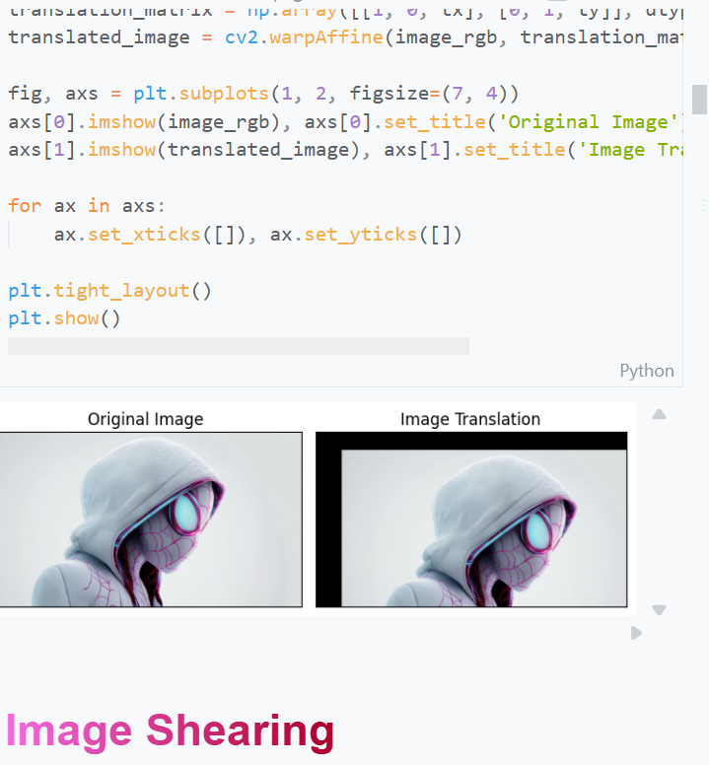
- 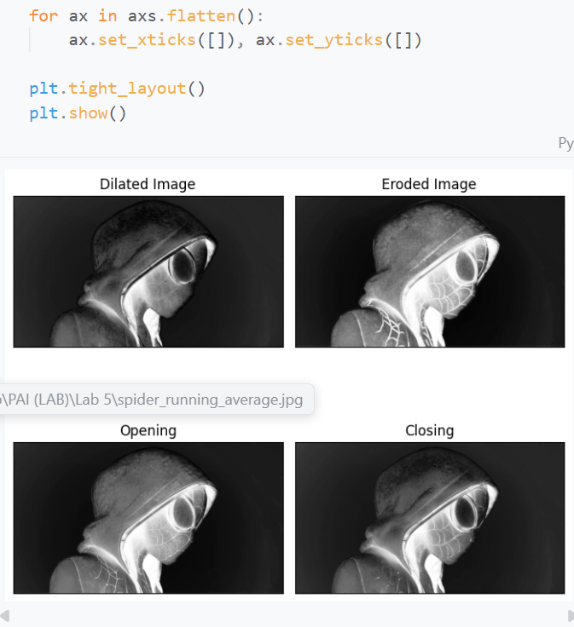
- 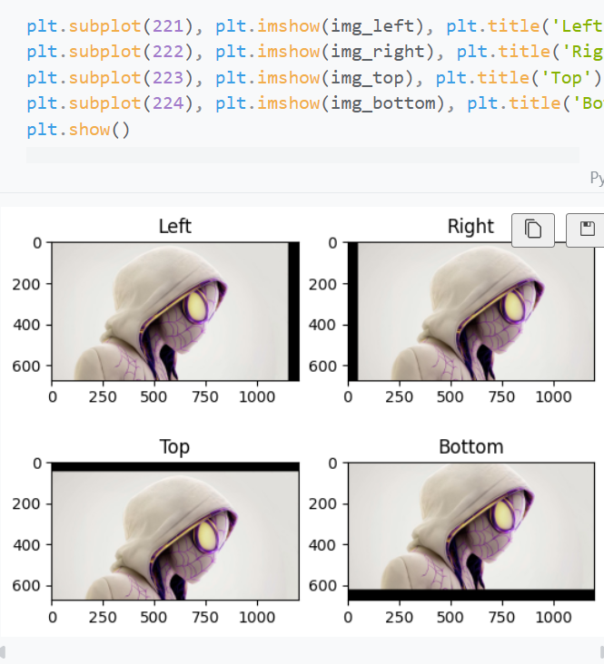

D. Mathematical Representation
Since the code handles images as arrays, the properties like shape and dtype are used.
- Purpose: To verify the image resolution and the number of color channels (e.g., 3 for color, 1 for grayscale).

4. Justification (The "Why")
- Why OpenCV? It provides highly optimized C++ backends for Python, making image processing extremely fast compared to standard loops.
- Why use Grayscale for analysis? Most structural features of an image (like edges and shapes) do not depend on color. Grayscale reduces the data size by 66%, making algorithms run faster.
- Why Matplotlib for display? In a Jupyter environment, cv2.imshow() can sometimes cause the kernel to crash. plt.imshow() is a safer and more integrated way to view results.

5. Visual Outputs
The final implementation demonstrates the transition from a raw BGR image to a processed, scaled, and color-corrected version ready for analysis
